**ASSIGNMENT-15.**

**Employee-ID:** 46248061.

**Question-1:**

**Program name:** z8061_alv

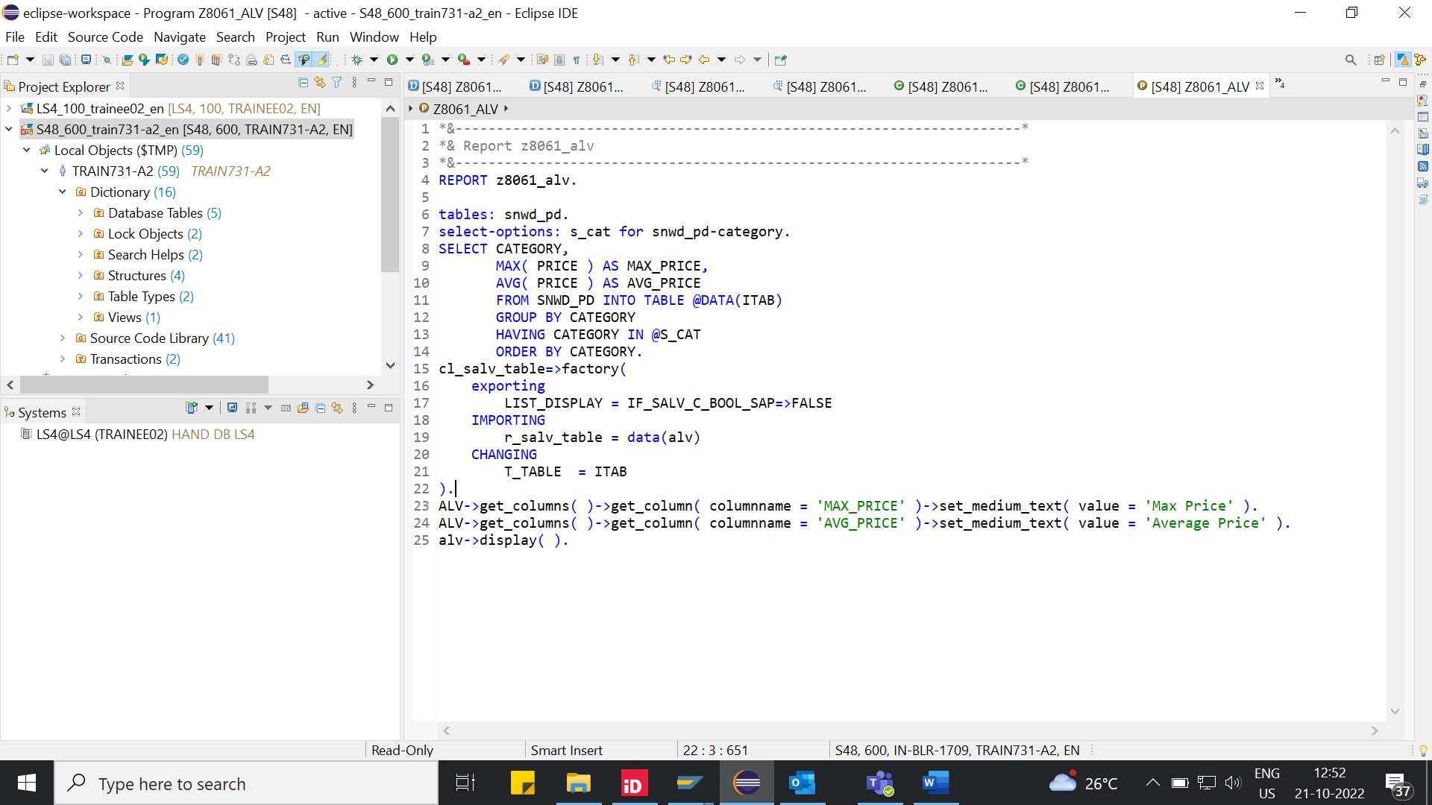

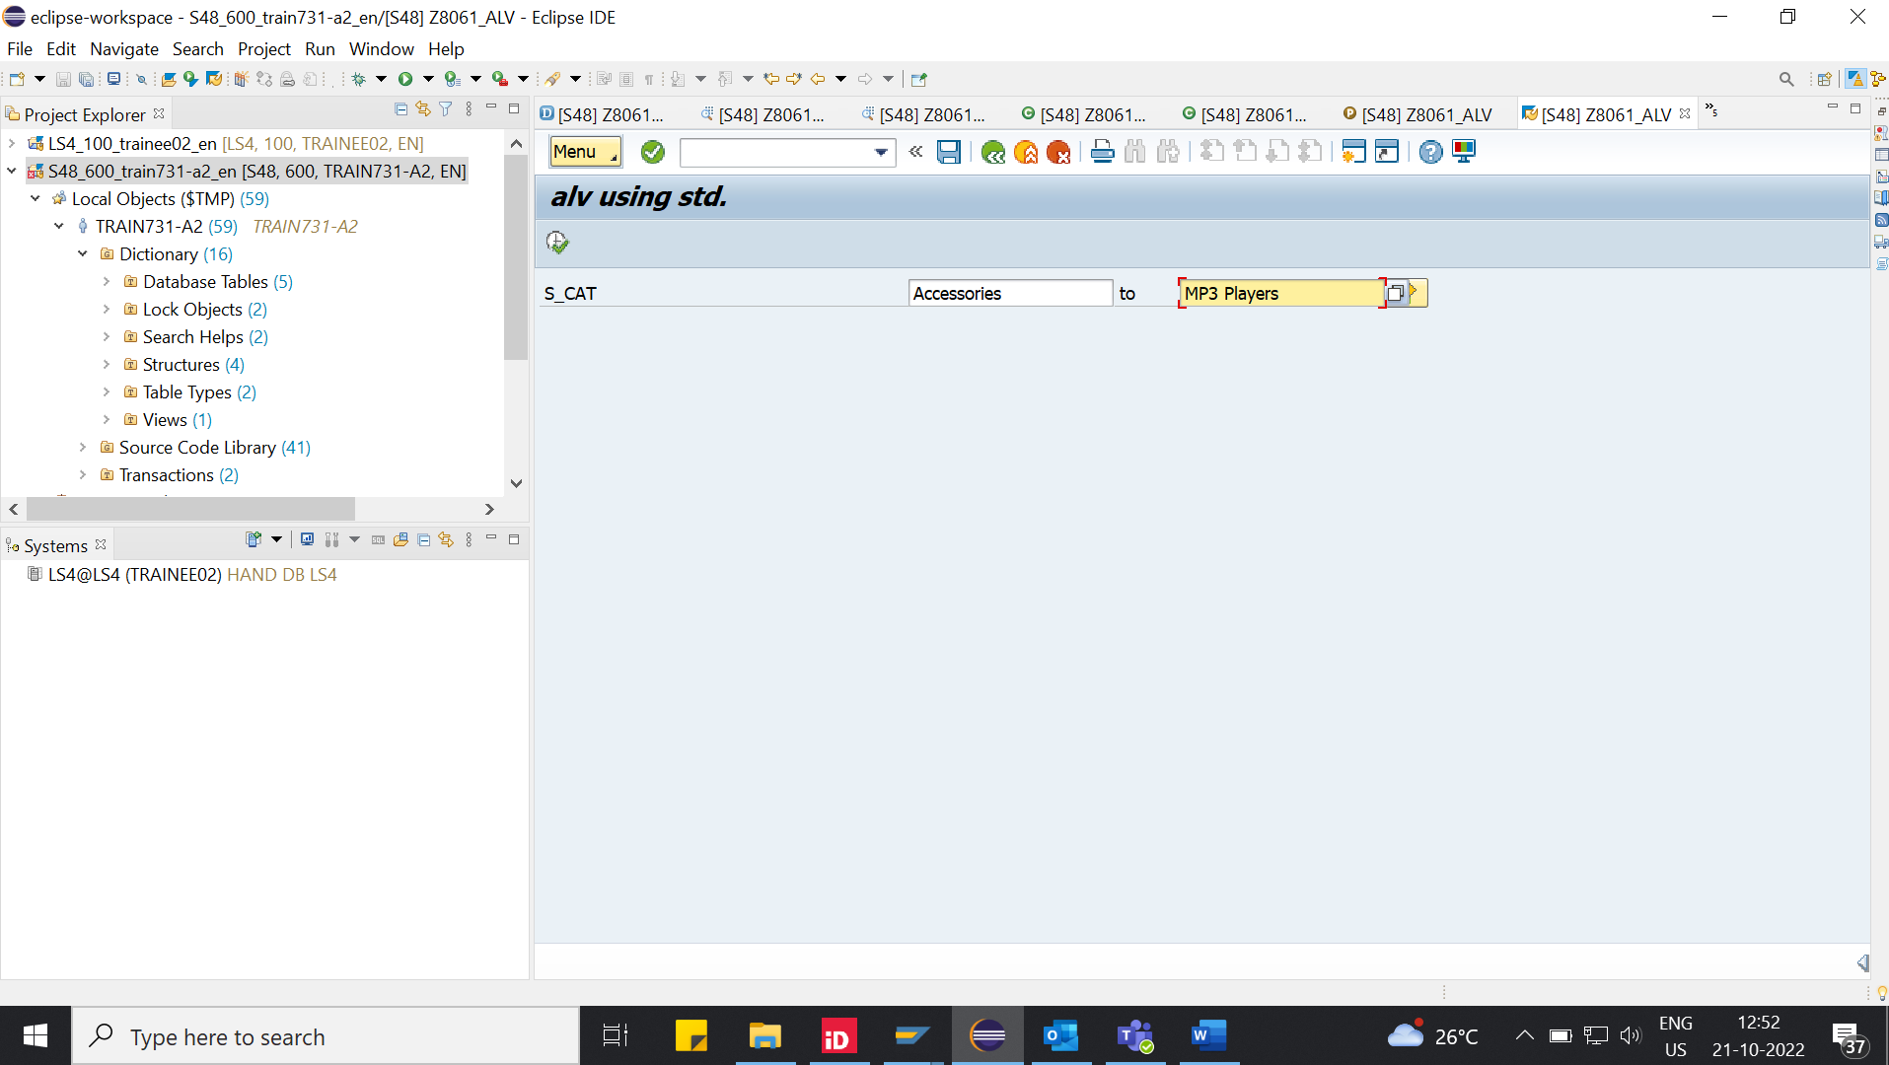

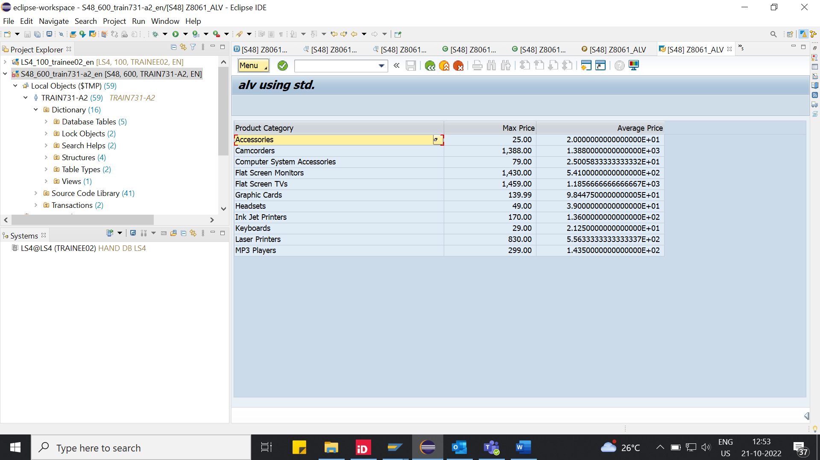

**Question-2:**

**CDS_VIEW:** Z8061_CDS_VIEW4.

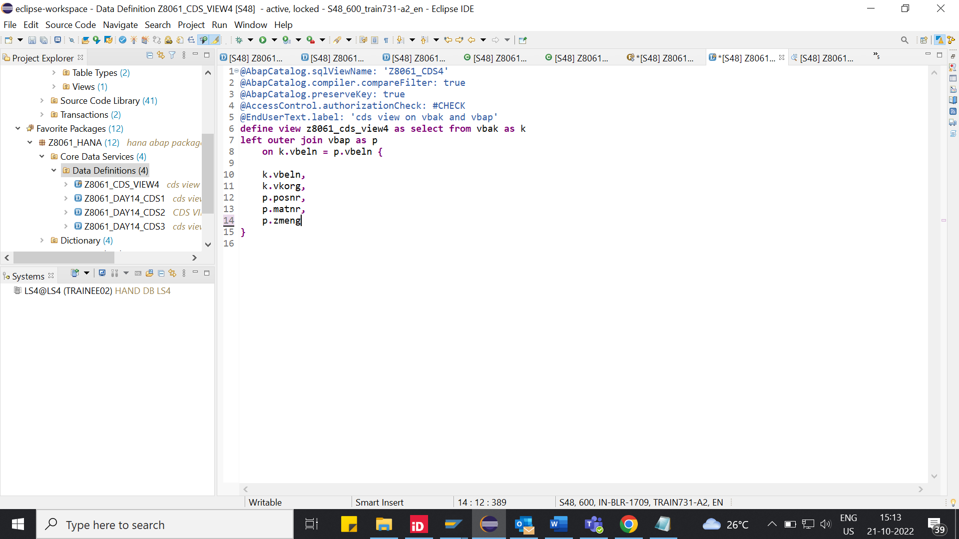

**Program name:** Z8061_DAY15_ALV_IDA

